**Selenium IDE**

Selenium IDE is a Firefox plug-in to develop Selenium test cases, it provides these features:

* Recording user actions
* Saving user actions as a reusable script
* Context menu in Firefox to add assertions and verifications
* Full editing of the test cases

The add-on works only in Firefox, but tests can be run in other browsers like Internet Explorer, Safari and Opera.

**Selenium IDE Installation**

Using Firefox, download the IDE from the SeleniumHQ.

Select Install Now.

Restart Firefox.

After Firefox reboots you will find the Selenium IDE listed under the Firefox Tools menu.



Icon appears at top-right corner of browser.

Question:

Create Selenium IDE Script to perform the following processes:

* Process #1: Recording a test script
* Process #2: Playing back / executing a test script
* Process #3: Saving a test script

**Process #1: Recording a test script**

Scenario:

Open “https://accounts.google.com”.

Assert Title of the application

Enter a valid username and password and submit the details to login.

Verify that the user is redirected to the Home page.

Step 1 – Launch the Firefox and open Selenium IDE from the menu bar. Click on “Create a new project”. Enter project name.

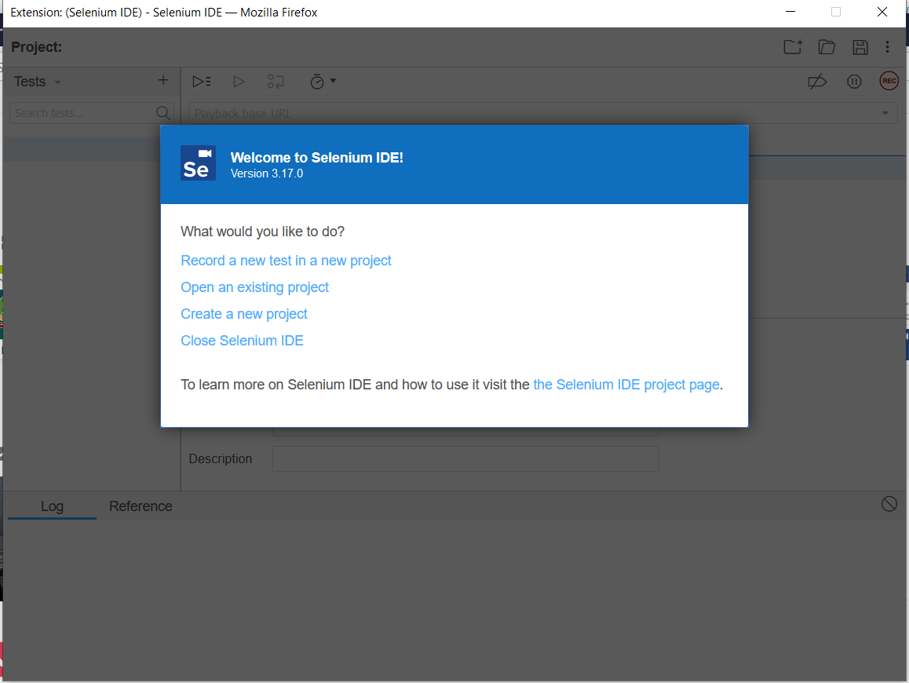 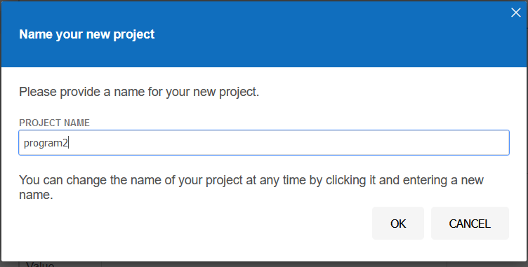

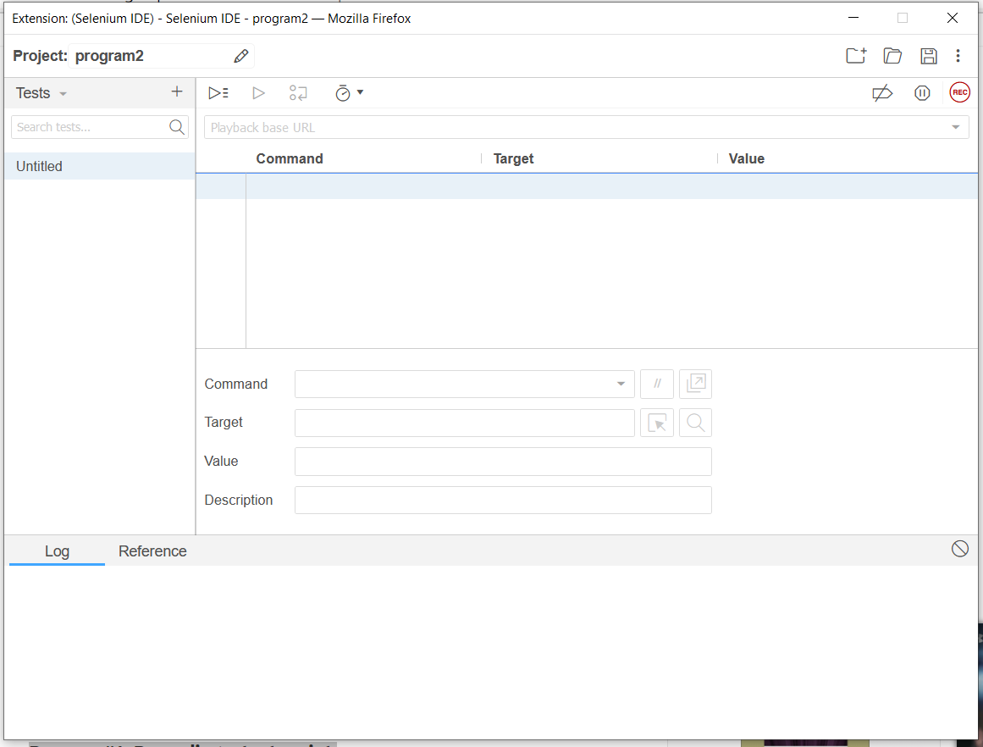

Step 2 – Click on Record button. Enter the address of application under test (“https://accounts.google.com”) inside the Base URL textbox. Click on Start Recording.

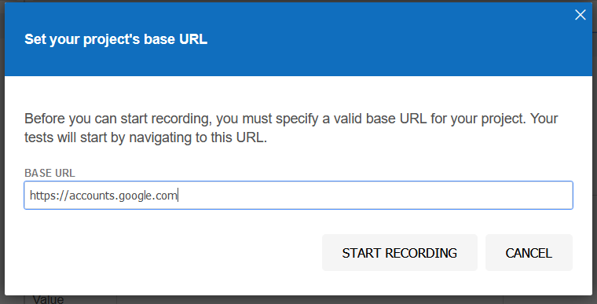

Step 3: Log in to sample mail id: test.seleniumst@gmail.com

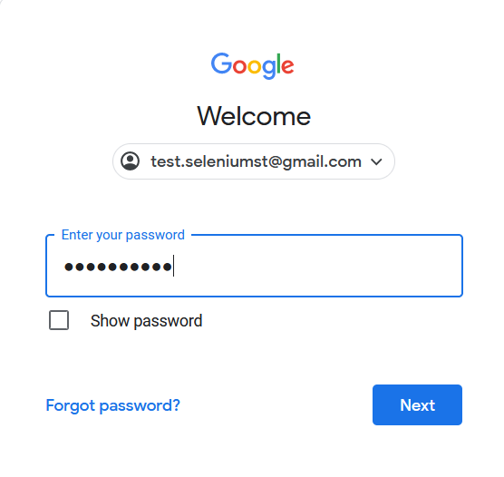

Step 4: In Selenium IDE, look for the following: assert tile, username and password.

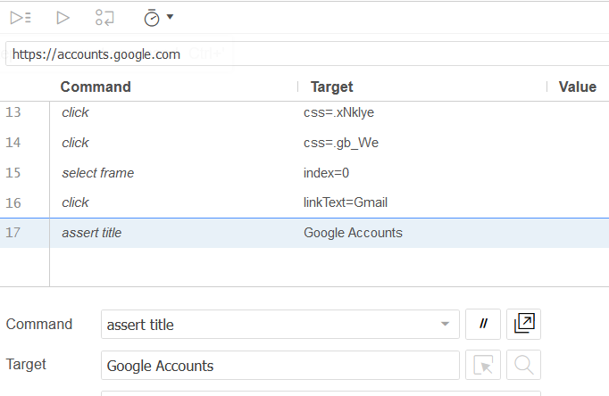 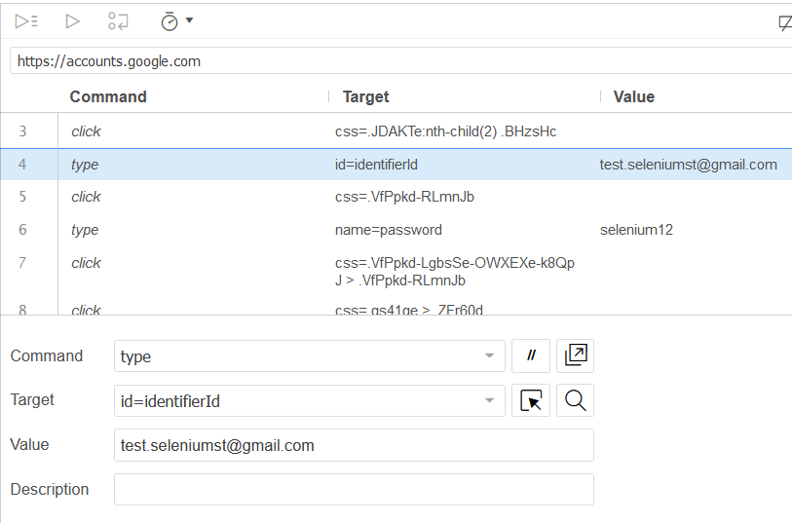 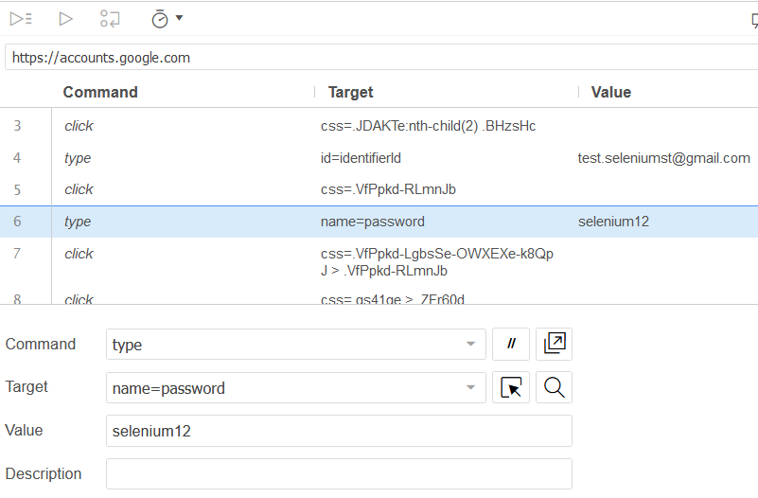

Step 5: Click on the “Sign in” button to complete the login process. The user is re-directed to the home page provided the credentials entered are correct. Stop the recording in Selenium IDE. Name the test and click on OK.

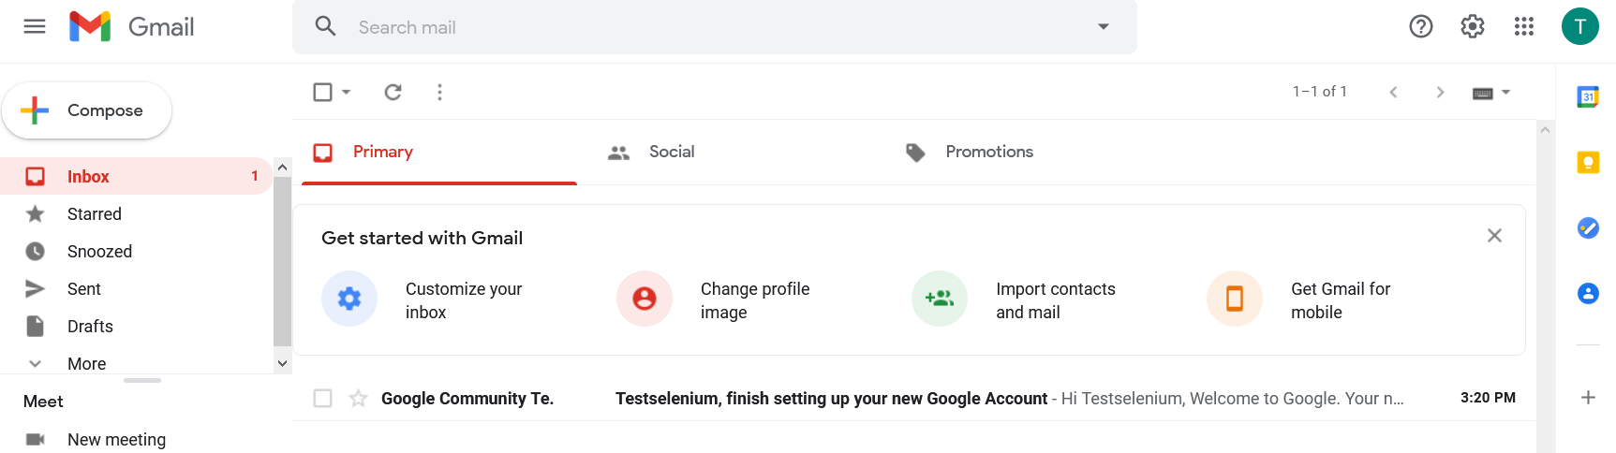

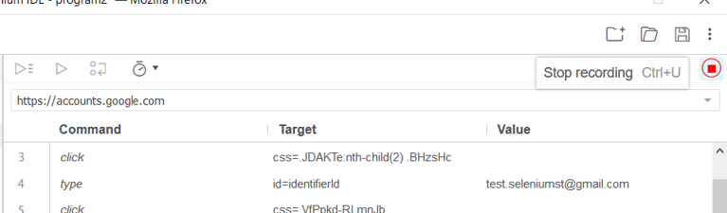 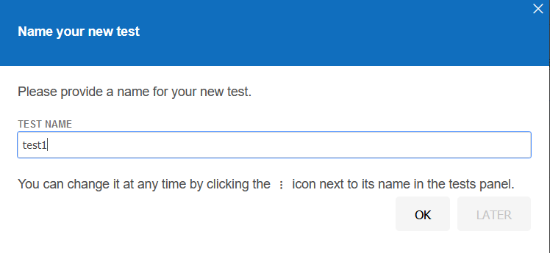

**Process #2: Playing back / executing a test script**

Click on the playback button to run current test case. If more than one test case is present then, all tests can be executed by clicking Run all tests playback button.

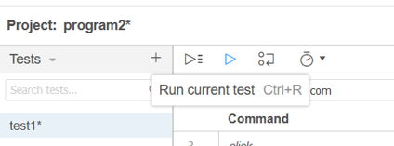 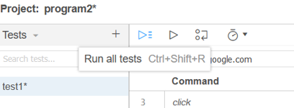

After executing test case, test case successful is displayed.

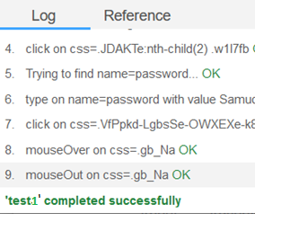

**Process #3: Saving a test script**

Click on the export option and save as Java Junit. The exported file is saved as “signup.java” (or any user defined name, .java is the extension).

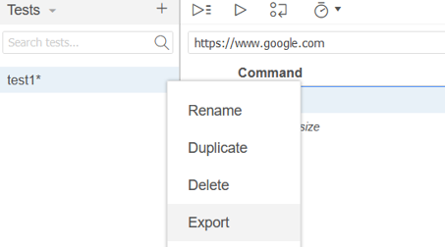 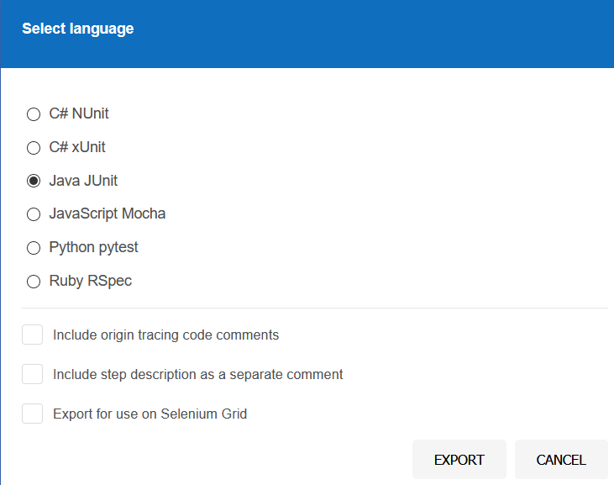

The project is saved using save option. The extension would be “.side”.

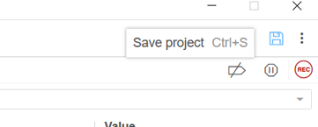

The java file exported can be viewed in eclipse IDE.

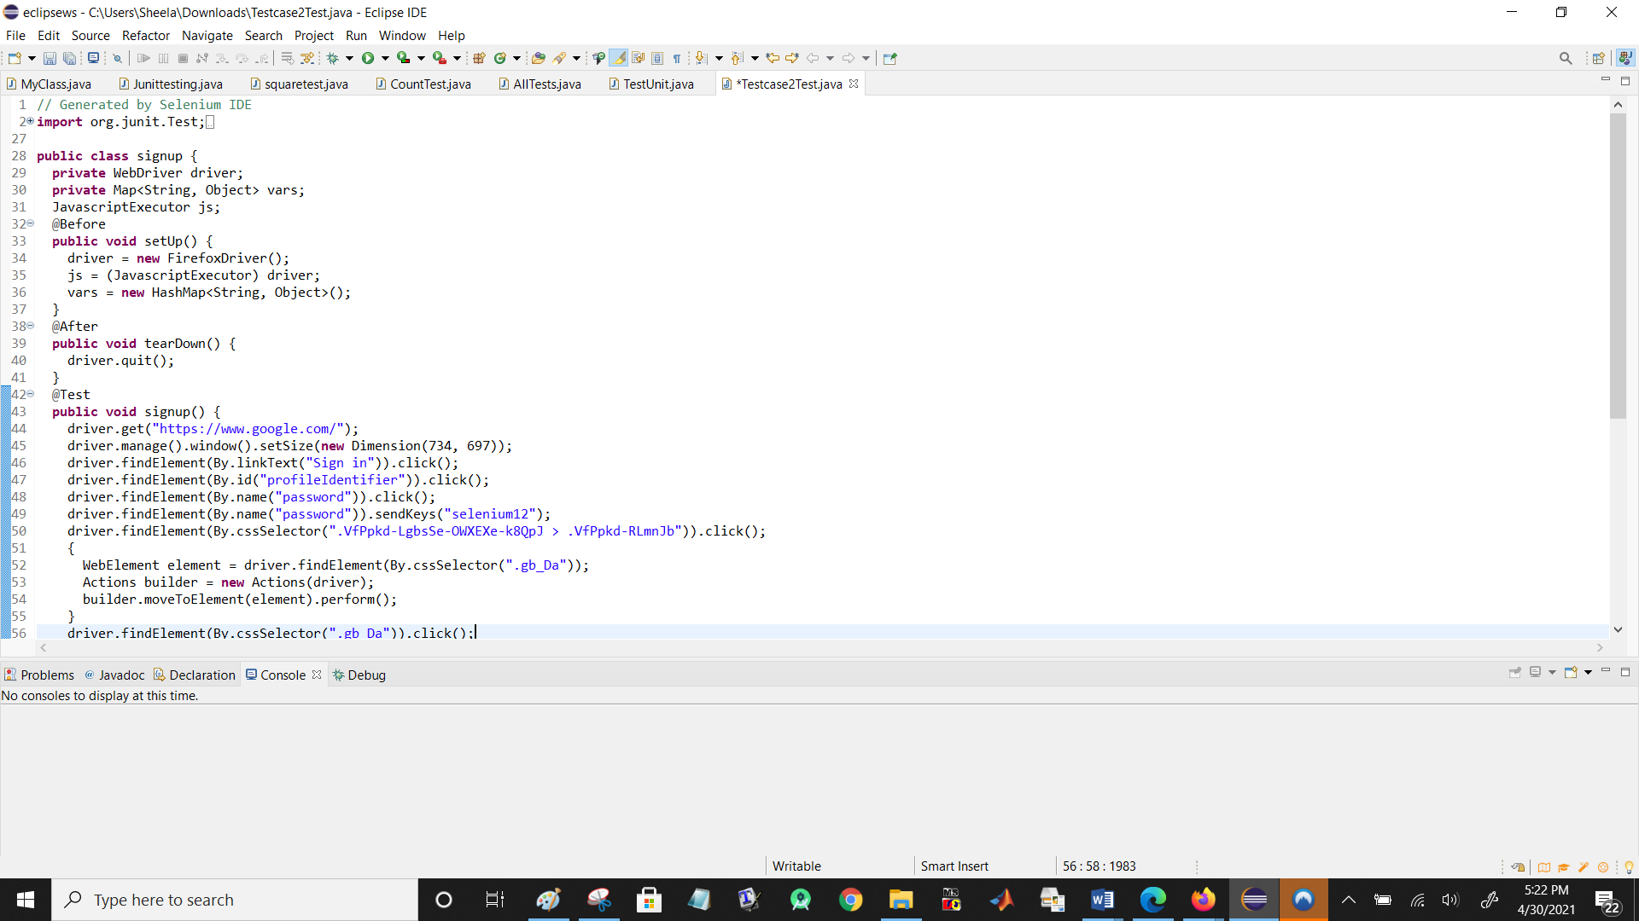

// Similarly try for scenarios that occurs during google sign up error, facebook registration etc.